Innovative die-cast zinc rectangular connector housing
EPIC® ULTRA for harsh Environments

Stuttgart/Hanover, April 4, 2011

The new EPIC® ULTRA has a modern appearance and a high-quality, shiny surface. This innovative new development in the field of EPIC® industrial connectors will be presented for the first time at the stand of the Stuttgart-based Lapp Group in Hall 11/C03 at the Hanover Fair.

The rectangular connector housing is absolutely scratch, impact and corrosion-resistant, making it ideal for use in harsh conditions, e.g. on offshore wind turbines and biogas power plants. When combined with the SKINTOP® Brush screwed cable gland, the connector is absolutely EMC-resistant, as the nickel-coated housing forms an all-over metallic shell that functions like a Faraday cage. This is especially important for the transmission of sensitive BUS signals.

The new housing combines a number of advantages: the SKINTOP® screwed cable gland is built into the shell, which guarantees the best possible sealing and strain relief, and also allows fast assembly, as the SKINTOP® does not need to be screwed in separately. The lip seal between the hood and the bottom part of the housing is inset to provide better protection against mechanical damage. The seal in the panel mount base that connects to the wall seal is also a built-in part of the housing. This prevents losses while also making installation easier. In short, the new housing protects the sheathed and shielded cables and the connector even better than before.

Another special featured is that, when connected, the housing provides a safe, 360°, metallic conductive connection, and can also be connected to standard housing units if required. "This makes the housing unique on the market. If users want safer and better-protected connections, they don't need to buy everything new. Instead, they can upgrade to the new housing units step-by-step," says Product Manager Guido Ege.

The new EPIC® ULTRA is slightly smaller than the old die-cast aluminium model and an even better fit, thanks to the thinness of the die-cast zinc walls. This gives developers and designers more room to play with, as the trend towards increasingly smaller products is also prevalent in the mechanical and plant engineering sectors. The clamping brackets are made of high-resistance stainless steel.

Guido Ege says: "With its new, innovative production technology, the EPIC® ULTRA represents the next generation of rectangular connectors. The user benefits are enormous."

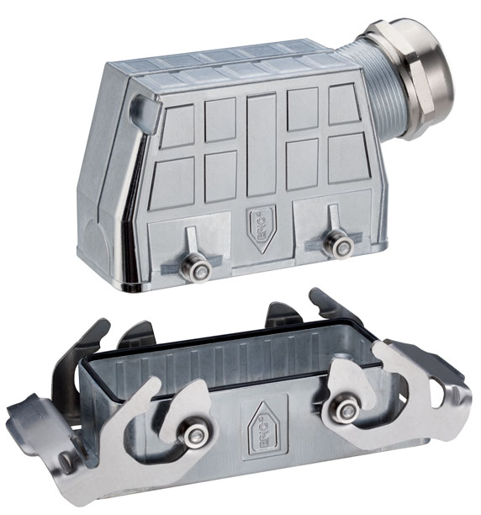
The EPIC® ULTRA is completely scratch, impact and corrosion-resistant – making it ideal for use in extreme conditions such as those encountered in offshore wind farms

Text and image available for download at www.lappkabel.com/news

About the Lapp Group:
Headquartered in Stuttgart, Germany, the Lapp Group is a leading supplier of integrated wire, cabling and connector products and solutions. Its offering includes electrical and fibre optic cables, industrial plug-in and screw connectors, cabling solutions, automation technology and technical accessories. Lapp Group’s core markets are in the mechanical and plant engineering and electronics manufacturing sectors, with rapid market expansion in the renewable energy, mobility and life science industries.

Lapp Group has remained in continuous family ownership since it was founded in 1959. In the 2009/10 financial year, it recorded total consolidated sales of 633 million euros. It employs some 2,800 people, operates 15 production sites and 40 sales companies and cooperates with approximately100 national partners worldwide.

