Two major events organized by Honorary Consul of India Andreas Lapp will strengthen ties between Germany and India
Building bridges between cultures with music and wine

Stuttgart/Mumbai, 16 January 2012

Andreas Lapp, Stuttgart-based businessman and Honorary Consul of the Republic of India, will be launching two major events in India in the next few days. Both are aimed at raising the profile of the state of Baden-Württemberg and Germany as a whole in India. The first of these is the “Stuttgart meets Mumbai” wine festival, which will take place for the eighth time in Stuttgart’s twin city of Mumbai. This year, the event will be held in parallel with celebrations marking 60 years of diplomatic relations between India and Germany. Andreas Lapp is also paying tribute to this milestone by sponsoring a second event: a concert tour by the Babelsberg Film Orchestra, which will perform works by famous Indian composer A. R. Rahman in five major Indian cities.

“Stuttgart meets Mumbai” wine festival
The “Stuttgart meets Mumbai” wine festival will take place on 21 and 22 January at the Taj Lands End Hotel in Mumbai. The aim is to give Indian visitors an impression of the Swabian way of life, by offering them the opportunity to sample wines from the region, tuck into local culinary specialties, enjoy some traditional folk music and find out more information from the various stands. This is the eighth time that the festival takes place in Mumbai, and it has become a real meeting point for politicians, entrepreneurs and representatives from the worlds of business, film, media and tourism, and the wine industry. The Lord Mayor of Stuttgart, Wolfgang Schuster, will also be attending the festival with a team of delegates. Honorary Consul Andreas Lapp comments: “The festival provides an ideal opportunity to network and socialize. Business people, cultural ambassadors and politicians can forge new contacts and strengthen existing ones, and this helps to build bridges between our two cultures.”

This year, regional vineyards Unser, Heinrich, Supp and Bihlmayer will be inviting festival-goers to taste their Riesling, Kerner, Trollinger and Lemberger wines.

The Pforzheim Technical College for Goldsmiths and Watchmakers will also be running a workshop at the festival, and the Baden-Württemberg film organization will be advertising Stuttgart’s ninth Indian film festival, “Bollywood and beyond”, which will run from 18 to 22 July 2012.

“Classic Incantations: Babelsberg performs A. R. Rahman”
To mark the 60th anniversary of the start of diplomatic relations between Germany and India, Honorary Consul Andreas Lapp is sponsoring a concert tour entitled “Classic Incantations: Babelsberg performs A. R. Rahman”. Indian superstar Allah Rakha Rahman, also known as the “Mozart of Madras”, has won two Oscars, a Golden Globe and two Grammy Awards as composer and performer, among many other impressive achievements. At the end of January, the around 100-strong German Babelsberg Film Orchestra will be performing his compositions to audiences in large concert halls in the cities of Mumbai, Delhi, Kolkata, Chennai and Bangalore. This is the first time that a Western orchestra has ever performed Indian music in India, and some 15,000 people are expected to attend in total. The concert tour is being presented exclusively by Lapp India. Andreas Lapp explains: “Music is a great way to bring people together. We are confident that this unique initiative will help people in Germany and India to connect on new levels.”

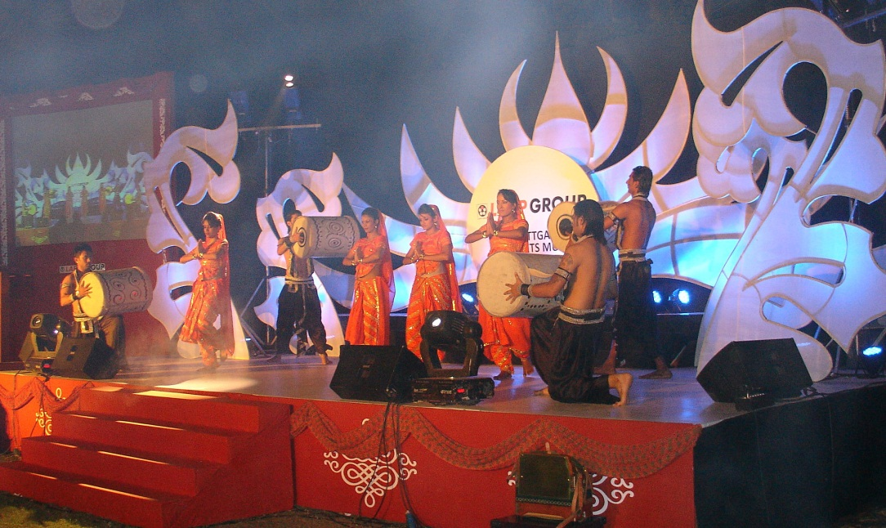
BU: Stage show at the 2011 wine festival

Image (jpg) and text (doc) available at www.lappkabel.de
News/Press

