New products at LAPP
Plug and Play for optical data transmission

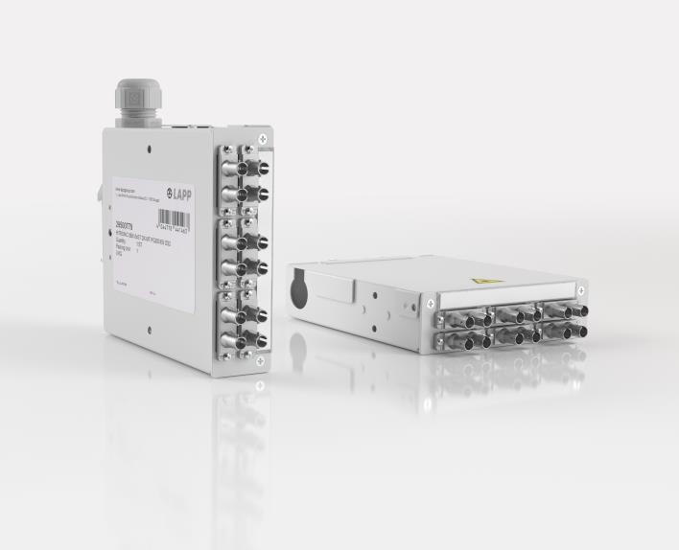
Image 1: LAPP’s new generation of splice boxes, HITRONIC SBX, are made of robust metal.

Stuttgart, July 22nd, 2019
The joining of glass fibres - the so-called splicing - requires a lot of experience and fine motor skills. And once the fibres are connected they can only be separated again by cutting. Pluggable connections are therefore better suited for the variable connection of terminal devices in industrial plants. For this purpose there are splice boxes with sockets, so-called pigtails, into which the optical fibres can be inserted in no time at all. With HITRONIC SBX LAPP presents a new generation of splice boxes made of robust metal for installation in switch cabinets. The HITRONIC SBX fit on TH35 mounting rails and can be mounted on them in three different positions, making it easier for the installer to insert the cables. The splice boxes comply with IP20, the protection class required in control cabinets, and the temperature range extends from -40°C to +70°C. The splice boxes can be used in a wide variety of applications. They are available in different versions with six or twelve ST Duplex, LC Duplex, SC Duplex or SC-RJ couplings and in all optical classes (OM1, OM2, OM3, OM4, OS2).

Tailor-made cables
This is only available from LAPP: the customer can order ready-made optical fibres to match the HITRONIC SBX splice boxes. They have the right length and are equipped with connectors, thanks to real plug and play the connection to the splice box is completed in seconds. And the customer can rely on optimum quality, because errors during manual assembly in the control cabinet are a thing of the past.

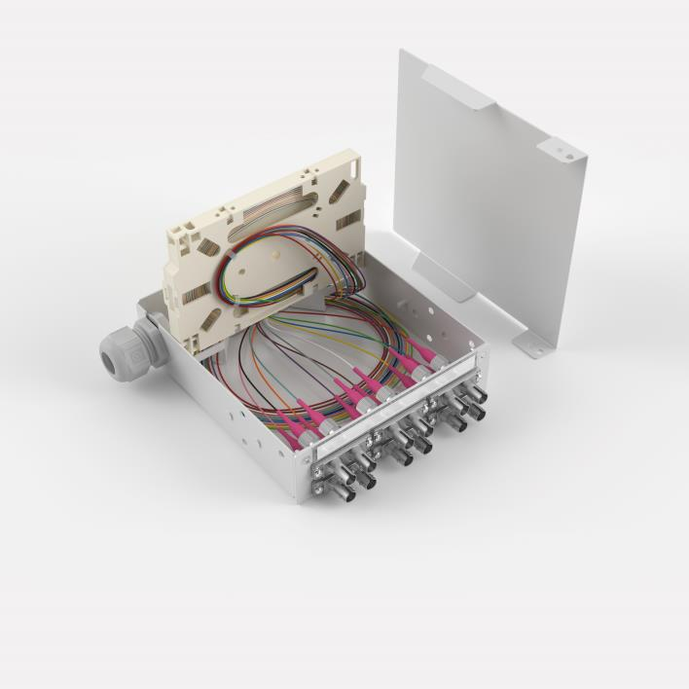
Image 2: The splice boxes HITRONIC SBX are available in different versions with six or twelve ST Duplex, LC Duplex, SC Duplex or SC-RJ couplings and in all optical classes

Find image 1 in printable quality here
Find image 2 in printable quality here

Press contact:
Dr. Markus Müller Irmgard Nille
Tel: +49(0)711/7838-5170 Tel.: +49(0)711/7838–2490
Mobil: +49(0)172/1022713 Mobil: +49(0)160/97346822
markus.j.mueller@lappgroup.com irmgard.nille@in-press.de

U.I. Lapp GmbH
Schulze-Delitzsch-Straße 25
D-70565 Stuttgart

Find more information here: www.lappkabel.com/press

About LAPP:
Headquartered in Stuttgart, Germany, LAPP is a leading supplier of integrated solutions and branded products in the field of cable and connection technology. The company’s portfolio includes standard and highly flexible cables, industrial connectors and cable entry systems, customized system solutions, automation technology and robotics solutions for the intelligent factory of the future, as well as technical accessories. LAPP’s core market is in the industrial machinery and plant engineering sector. Other key markets are in the food industry as well as the energy and the mobility sector.
LAPP has remained in continuous family ownership since it was founded in 1959. In the 2017/18 business year, it generated consolidated revenue of 1,153 million euros. LAPP currently employs approximately 4,245 people across the world, has 18 production sites and around 44 sales companies. It also works in cooperation with around 100 foreign representatives.

