More and more Indian companies looking to settle in Stuttgart
Further Expansion for Indian Business Center

Stuttgart, 17 September 2010

Germany has the largest population of all European countries and is well known for the many leading international companies located there. For Indian companies looking to expand operations, this market is a particularly attractive one. The Indian Business Center (IBC) helps Indian companies establish themselves in Germany. Its offices, located in Stuttgart and home to the Lapp Group, leading supplier of integrated cabling and connector products and solutions, are working to almost full capacity. Which is why the IBC is set for expansion: "We've generated plenty of interest in this centre and our plan is to develop it further", explains Andreas Lapp, Chief Executive Officer of the Lapp Group and Honorary Consul to India for Baden-Württemberg and the Rhineland Palatinate. Together with the Lord Mayor of Stuttgart, Dr. Wolfgang Schuster, Lapp has played a key role in setting up this centre.

Among the tenants currently occupying office space in Stuttgart are companies who represent the mechanical engineering and automotive industries, the software industry, wholesale trading, tourism and construction. As Andreas Lapp explains further: "I think it is important that we strengthen the economic ties between Germany and India. With the IBC Stuttgart, we are providing the smaller and medium-sized Indian companies in particular with the opportunity to gain a foothold on the German market". And, according to Lapp, Stuttgart is the ideal location for this: Centrally located at the heart of Europe, it is an easily accessible region of Germany which boasts a superb infrastructure. The area is well known for the many high-tech companies which are based here, such as Daimler, Porsche, Bosch, Lapp Group itself, and the German subsidiaries of IBM and Hewlett Packard. It has the greatest concentration of scientific research institutes in the country, with many internationally recognised institutes among them.

More than just reasonable office rent
IBC Stuttgart not only provides Indian companies with a superb location but it supports them in their efforts to establish their business in Germany, putting them in contact with lawyers, tax consultants and banks and providing assistance regarding any official matters. Meetings with IBC management consultants are set up to discuss suitable business strategies. And employees, who not only speak German and English but also Hindi and Kannada, are on hand to help the new residents settle in - providing information on everything from finding accommodation to Bollywood DVD rental. With its excellent infrastructure, the presence of internationally renowned companies primarily active in the mechanical engineering and automotive sectors, as well as a superb location right at the heart of Europe, it is no wonder that Stuttgart is a popular choice among Indian companies.

Stuttgart's Lord Mayor, Dr. Wolfgang Schuster, is delighted to see the Indian Business Center enjoy such success: "Thanks to the dedication shown by Andreas Lapp, Stuttgart has become a small enclave for the Indian community. This is seen in the success of IBC. It contributes to the establishment of new companies here in the region, facilitating a lively economic exchange between national and international businesses. In the end, we all stand to profit.".

The Indian tenants are also impressed. "Stuttgart is an interesting market for our machine tools. We are thus very grateful for the support and encouragement we receive from IBC", says K. S. Raju from the Aksar Group which has its headquarters in Bangalore. "The IBC is more than just an office. Being involved with the IBC has improved our corporate image. And it has certainly helped us to gain a foothold on the German market", says Manoj Babu from Medicus Ayurbay Beach Resort. Dhruv Khanna from Arya Tea Co. GmbH: "IBC has provided us with new opportunities to make contact with potential customers. This is our chance to grow."

Everyone is benefitting from the German-Indian economic relationship: There are 347 Baden-Württemberg companies represented in India and 38 Indian companies are currently active in Baden-Württemberg. And this trend continues to rise. Andreas Lapp: "The more successful our Indian companies are, the greater the potential for creating new jobs in the region."

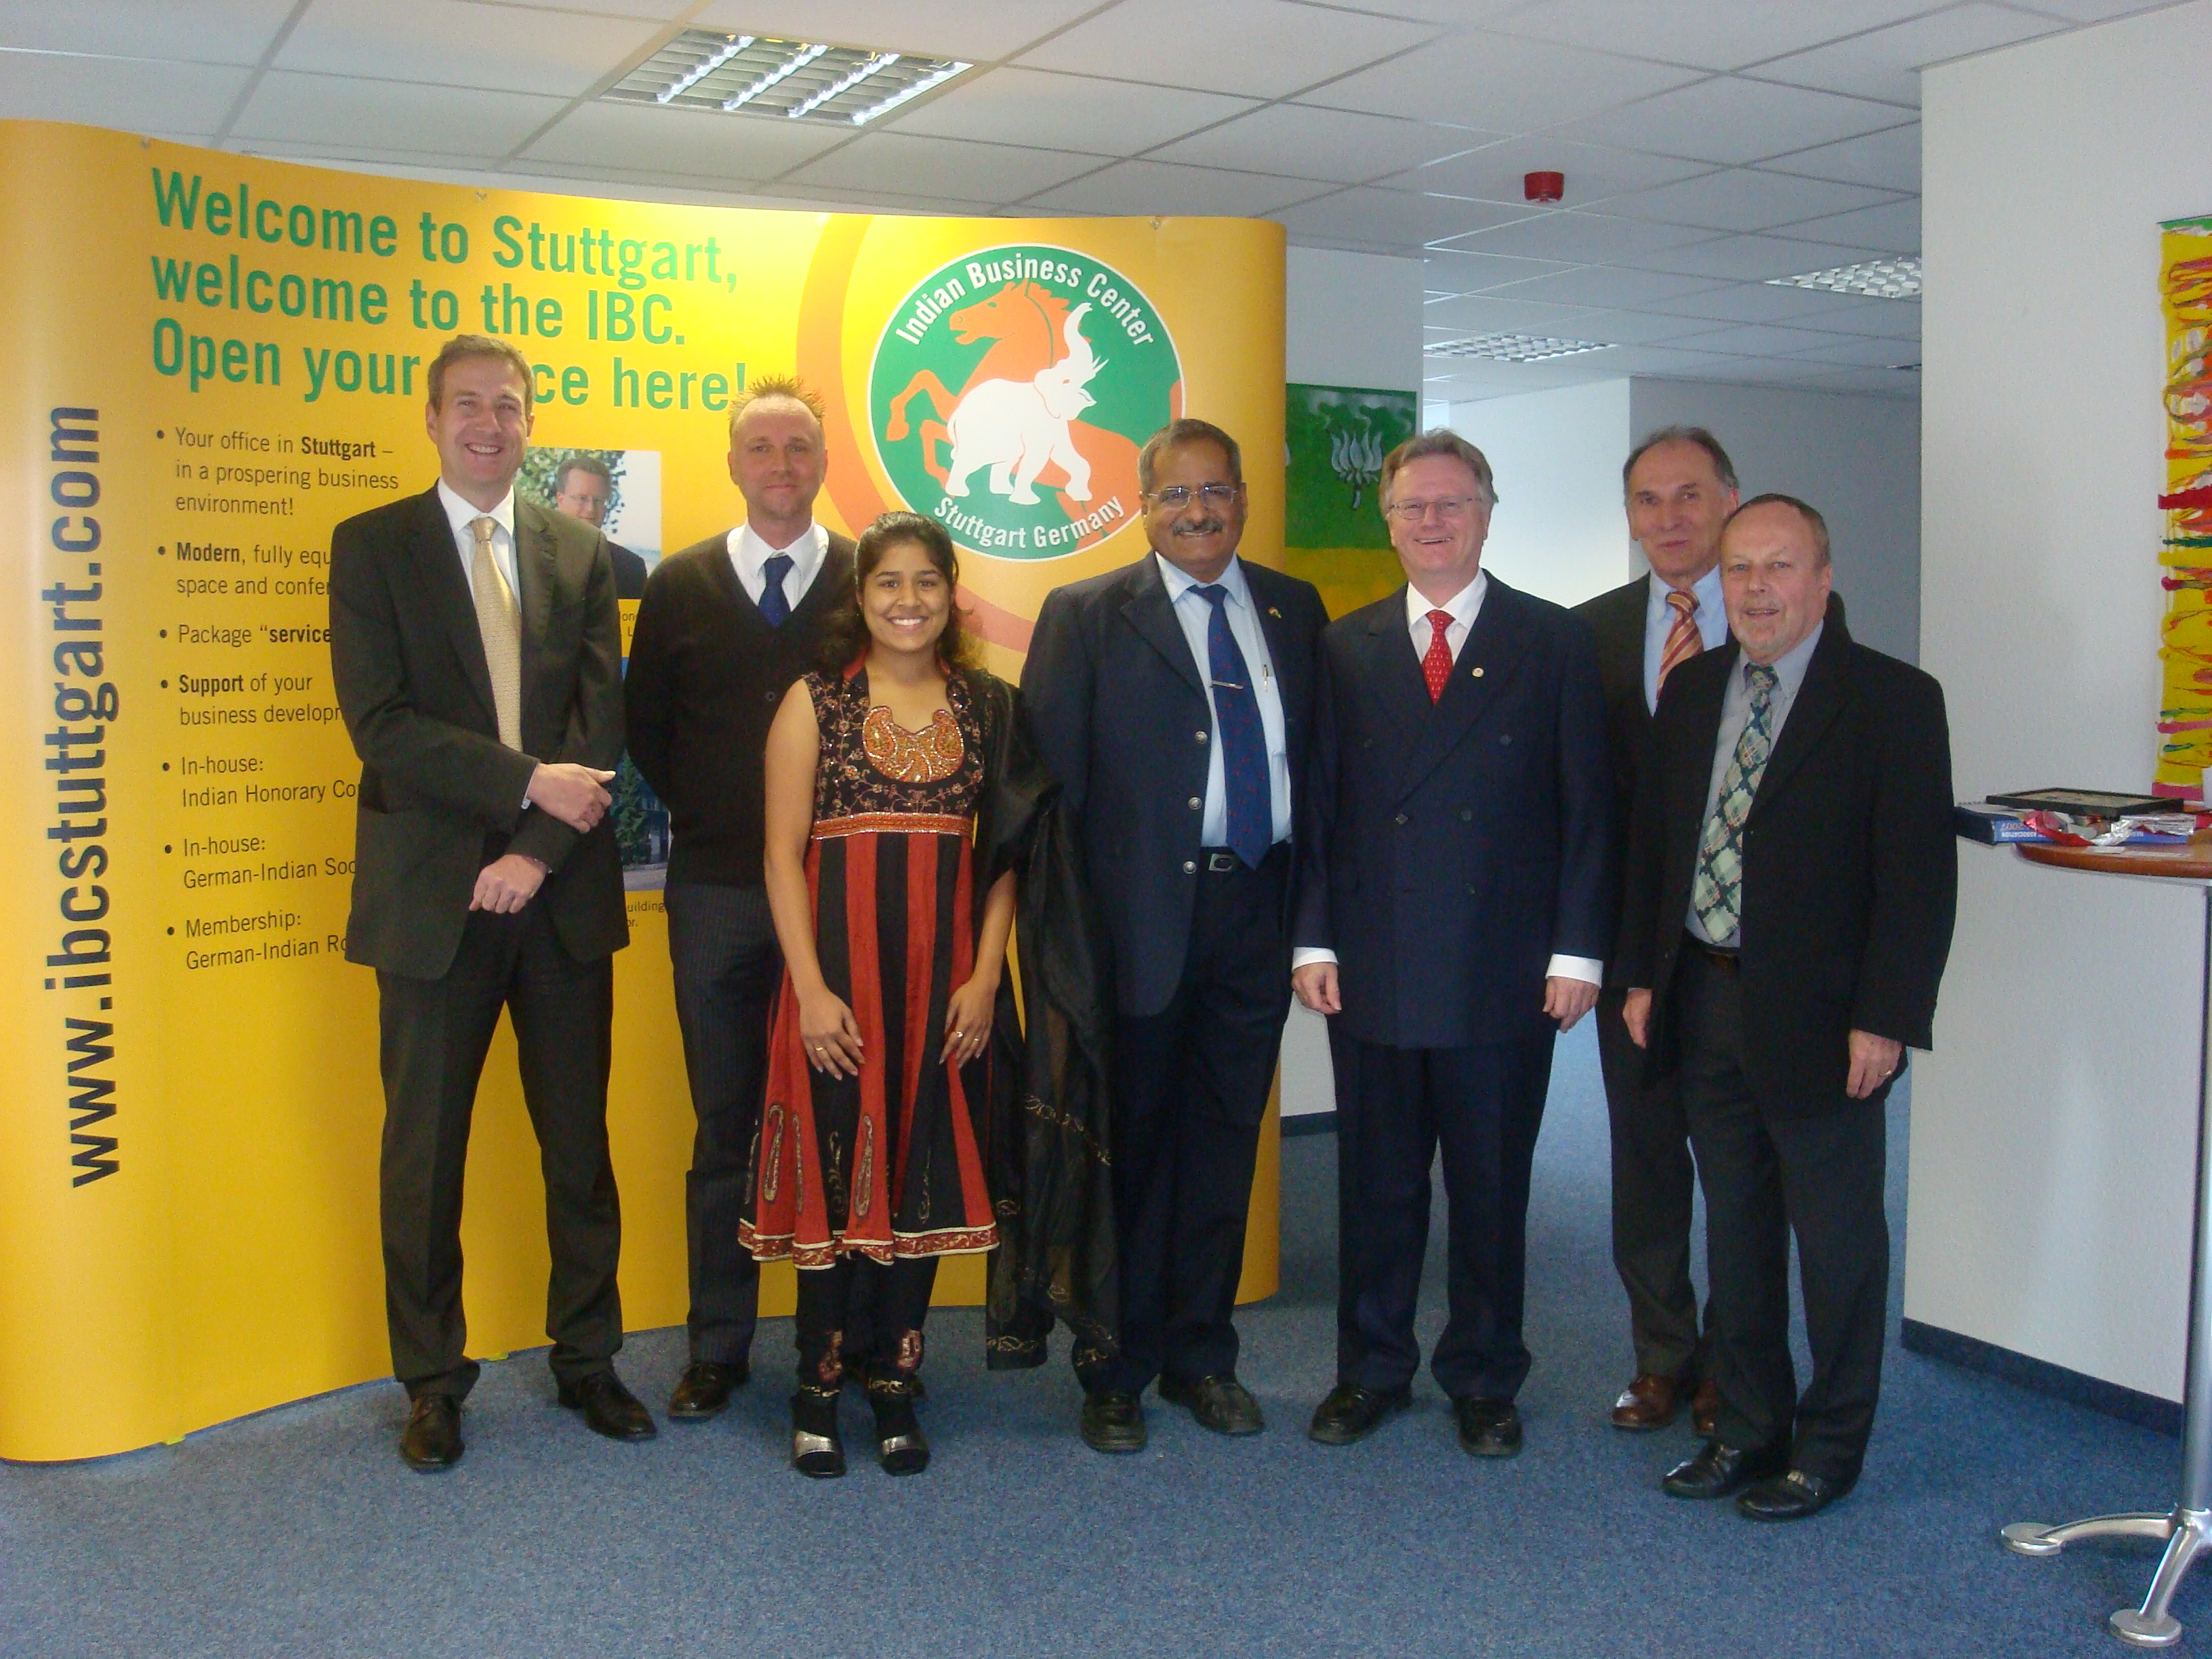
Caption:
The team from the Indian Business Center, with Honorary Consul Andreas Lapp (third from right), welcomes new tenants.

Image and text (doc) at www.lappkabel.de
Current news/ Press

About the Lapp Group:
With its headquarters in Stuttgart, Germany, the Lapp Group is a leading supplier of integrated cabling and connector products and solutions. Its product portfolio includes fibre optic and electrical cables, industrial plug-in and screw connectors, bespoke cabling solutions, automation technology and technical accessories. The Group’s core markets are in the mechanical and plant engineering and electronics manufacturing sectors and it is also expanding rapidly in the renewable energy, mobility and life science industries.

The Group has remained in continuous family ownership since it was founded in 1959. In the 2008/09 financial year, it recorded total sales of 508 million Euro. It employs some 2,600 people and operates 16 manufacturing sites, 40 distribution subsidiaries and more than 100 foreign representative offices.

