Lapp Group launches new multi-purpose cable for the solar industry
Lapp Group expands PV range with new ÖLFLEX® TRAFO cable

Stuttgart, January, 13, 2011

Lapp Group, one of the world’s leading providers of integrated wire, cabling and connector products and solutions, has launched a new type of power cable for the voltage range up to 1.8/3kV. The new product will be sold under the ÖLFLEX® TRAFO brand name. Together with the company’s existing range, it means that Lapp Group can now offer an integrated solution for all the solar industry’s cabling needs. ÖLFLEX® TRAFO was developed in partnership with SMA Solar Technology, the global market and technology leader in solar inverters, within the space of just eight weeks. It is specifically designed for connecting inverters to medium-voltage transformers, so that energy generated from the sun can be relayed directly to the high-voltage network.

Suitable for use around the world, even in extreme temperatures
SMA’s key design requirements were flexibility and durability. In addition to having the required current-carrying capacity, ÖLFLEX® TRAFO had to be suitable for laying underground with no additional protection, and to this end it was given a reinforced outer sheath. This is made from an electron beam cross-linked material that is highly resistant to UV, ozone and environmental stresses.

The new medium-voltage cable is also suitable for use across an exceptionally wide temperature range (from -40°C to +100°C), making it suitable for PV systems in areas with extreme climatic conditions. This includes off-grid facilities in infrastructure-poor regions, which make use of renewables in an increasing extend to meet their electricity needs.
The recent introduction of new international standards means that the cable can be used almost anywhere in the world, for applications not just in the field of power generation, but also in machine and plant engineering. Lapp Group is also already working on a variant of the product with a special strand design that will enable it to be used as a torsion cable in wind power generating facilities.

Lapp Group is confident that the new product will prove a success in the international market. “This new product was developed in response to the specific requirement of the global market leader SMA for a higher-voltage cable suitable for its inverters, which have a higher output voltage than is typical,” says Michael Collet, head of the Lapp Group’s Renewable Energy division. “ÖLFLEX® TRAFO is the first durable, affordable cable with such a high voltage rating that can be ground-laid, and as such we expect a positive response from the market.” SMA too is happy with its relationship with the Lapp Group. “Lapp responded very quickly to our enquiry and developed the new cable to meet our needs – just as we would expect from our long years of working together with them,” says an SMA representative.

Lapp Group – providing integrated solutions for the renewables industry
In recent years, Lapp Group has developed a range of innovative products that have enabled it to position itself as an integrated solutions provider to the renewable energy industry. In addition to ÖLFLEX® TRAFO, its photovoltaic products include the slimline, ultra-low-resistance EPIC® SOLAR 4 Thin solar connector, ÖLFLEX® solar cables, SKINTOP® cable glands and FLEXIMARK® cable marking products. “With the launch of the new ÖLFLEX® TRAFO, we now cover all the solar industry’s cabling needs, from the PV module to the connection to the high-voltage grid,” says Collet. “This enables our company to partner with manufacturers of solar products, but also installers and project developers for all kinds of PV projects.”

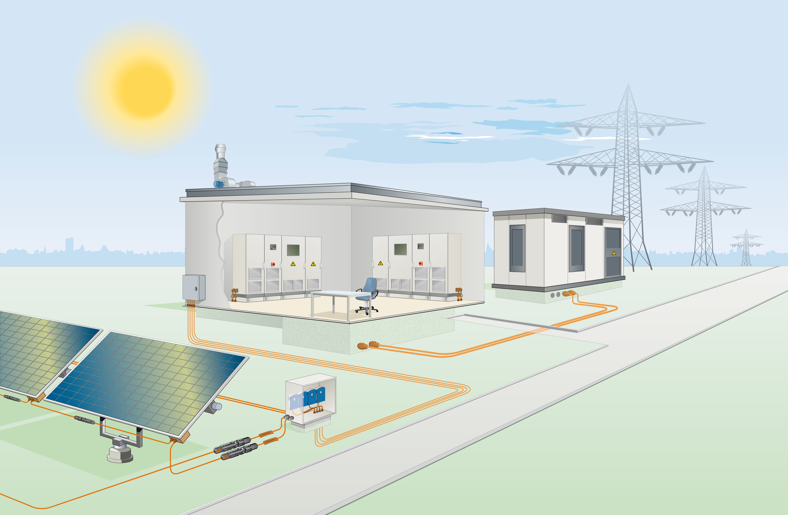
(Caption)
Lapp Group now offers a complete range of pholtovoltaic products, from ÖLFLEX® TRAFO cabling to FLEXIMARK® cable marking products.

Text and image available for download at www.lappkabel.com/news

About the Lapp Group:
Headquartered in Stuttgart, Germany, the Lapp Group is a leading supplier of integrated wire, cabling and connector products and solutions. Its offering includes electrical and fibre optic cables, industrial plug-in and screw connectors, cabling solutions, automation technology and technical accessories. Lapp Group’s core markets are in the mechanical and plant engineering and electronics manufacturing sectors, with rapid market expansion in the renewable energy, mobility and life science industries.

Lapp Group has remained in continuous family ownership since it was founded in 1959. In the 2009/10 financial year, it recorded total consolidated sales of 633 million euros. It employs some 2,800 people, operates 15 production sites and 40 sales companies and cooperates with approximately100 national partners worldwide.

About SMA Solar Technology AG
SMA Solar Technology AG develops, produces and sells solar inverters and monitoring systems for photovoltaic applications. SMA is the world’s largest producer in this segment and is the only vendor that has a product range with the matching inverter type for any module type and any power class. This applies for grid tied applications as well as island and backup operation.
The inverter is technologically the most important component in any solar power system: it converts the direct current generated in photovoltaic cells into alternating current suitable for the grid. In addition, it is an intelligent system manager, responsible for yield monitoring and grid management. Solar inverters are characterized by a particularly high efficiency. The Sunny Mini Central produced by SMA already has an efficiency of over 98 %, which allows for increased electricity production.
SMA’s business model is driven by technological progress. Due to its flexible and scalable production, SMA is in a position to quickly respond to customer demands and promptly implement product innovations. This allows the Company to easily keep pace with the dynamic market trends of the photovoltaic industry and at the same time absorb short-term fluctuations in demand for solar inverters.
SMA Solar Technology AG is headquartered in Niestetal, near Kassel, and is represented on four continents by 15 foreign subsidiaries.

This group of companies employs more than 5,000 employees (incl. temporary employees) and has been distinguished several times in previous years with awards for its outstanding performance as an employer. Since June 27, 2008, the Company has been listed in the Prime Standard of the Frankfurt Stock Exchange (S92), and since September 22, 2008, the Company’s shares have been listed in the TecDAX. In 2009, SMA generated an earnings before interest and taxes (EBIT) of more than € 228 million from a turnover of more than € 934 million. This corresponds to an EBIT margin of over 24 %.

